ShopNest Sales Dashboard Project Report

This comprehensive sales dashboard gives us the visual insights using power BI and other necessary tools to clean and sort data for better visualisation for the ShopNest sales data for better analysis.

Every single sections Takes us to a specific business parameters, featuring the visualisation uses and an explanation is provided along with it.

The ultimate aim is to present data in such a way that decision makers can append the clear understanding of sales performances.

Q1. **Top Categories by Total Price:**

* + Identify and visually represent the top 10 product categories by total sales.

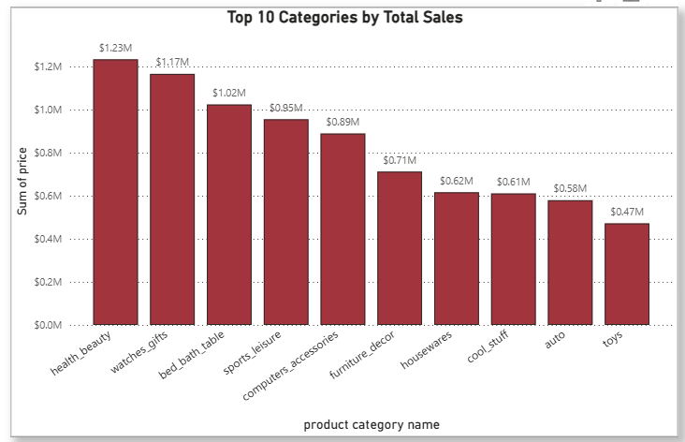

This Clustered bar chart visualizes the top 10 product categories based on total sales. Categories are ranked by adding the price of sold items.

It helps identify best-selling categories and where the revenue is most concentrated.

It helps us know the demand of specific category so to maintain its constant supply.

**Q2.Delayed Orders Analysis:**

* + Determine the number of delayed orders in each category. An order is considered delayed if the actual delivery date is later than the estimated delivery date.

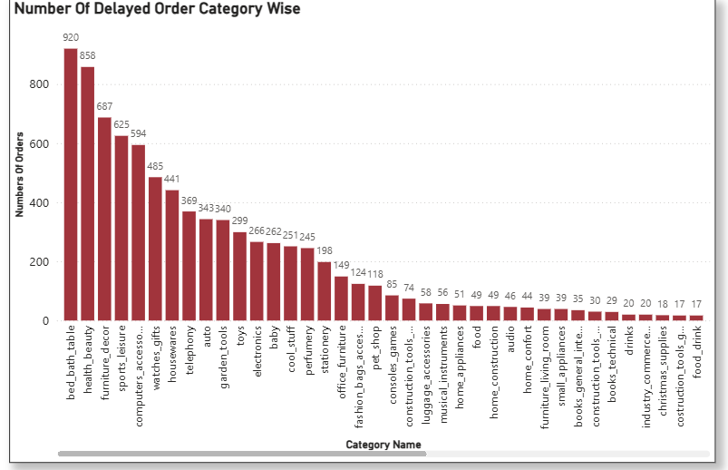

This chart displays the count of delayed orders within different product categories. Delays are determined by comparing the estimated vs actual delivery dates. This helps identify operational inefficiencies or logistics issues.

By this we can find out the reason of delayed orders as to maintain good revenue generation by eliminating any inefficiencies.

Q3. **Monthly Comparison of Delayed and On-Time Orders:**

* + Create a dynamic visual that compares the number of delayed orders to the number of orders received earlier for each month. Utilize the drill through cross-report feature to provide a detailed analysis of late and on-time deliveries.

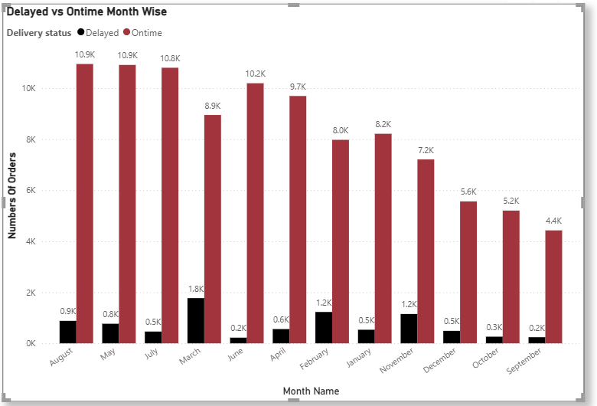

A Clustered Bar chart compares delayed vs on-time deliveries over each month. This view shows if delays are seasonal or improving over time. Drill through enables users to explore detailed delivery data per month.

Q4. **Payment Method Analysis:**

* + Analyze the most frequently used payment methods by customers using a visually appealing representation, such as a pie chart or other suitable visuals.

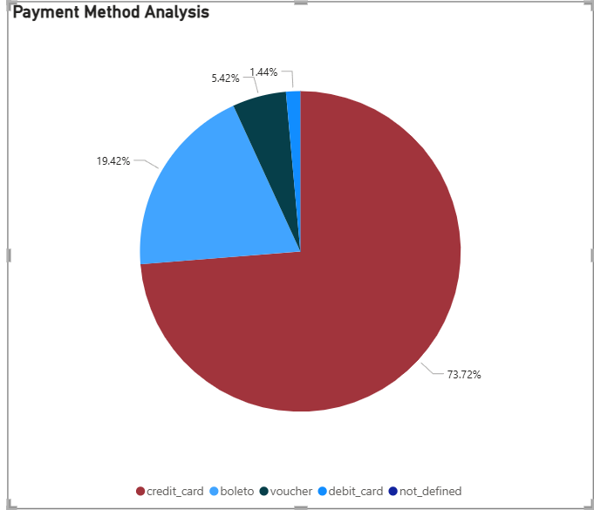

This pie chart shows the distribution of different payment methods used by customers. It highlights the most popular modes and customer preferences, which is useful for optimizing checkout and transaction support.

Q5. **Product Rating Analysis:**

* + Determine the top 10 highest-rated products and the bottom 10 lowest-rated products using a bar or column chart.

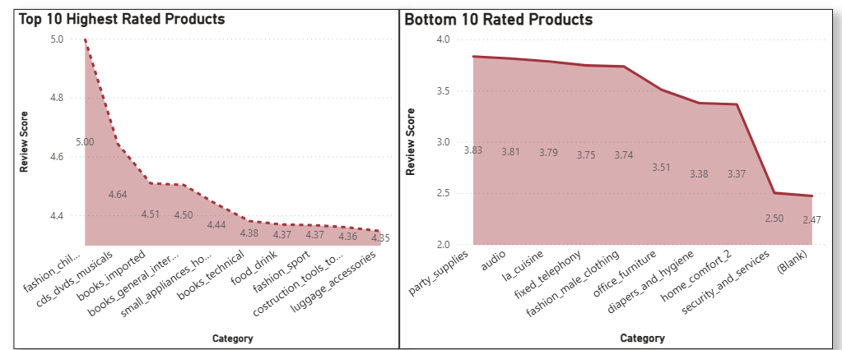

Two Stacked area charts display the highest-rated and lowest-rated products based on customer reviews. This analysis helps identify product strengths and weaknesses from a user satisfaction perspective.

Q6. **State-wise Sales Analysis:**

* + Identify and visually represent states with high and low sales, providing a clear understanding of regional sales performance.

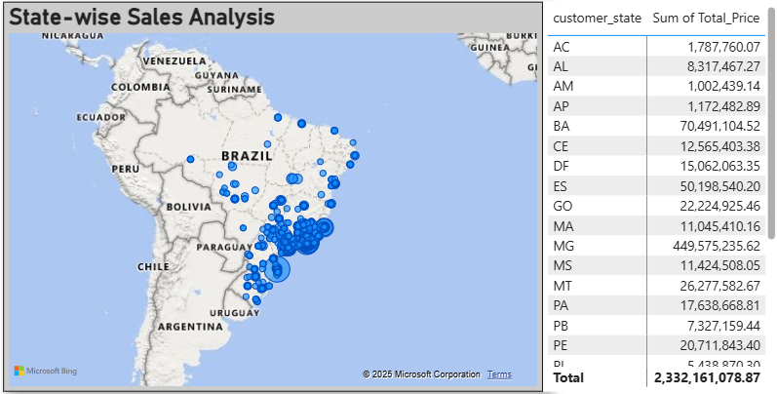

A map visual uses geolocation data (lat/lng) to represent state-wise sales. Bubble size indicates revenue volume. It helps identify high-performing and low-performing regions geographically.

Another one is matrix which gives the figures of revenue per state.

Q7. **Seasonal Sales Patterns:**

* Investigate and visualize any seasonal patterns(Quarterly) or trends in sales data over the course of the year.

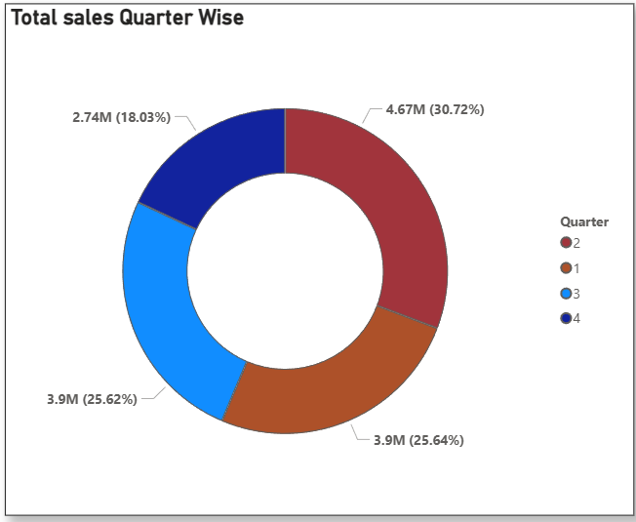

This Donut chart shows sales trends across each quarter to identify seasonal buying patterns. It helps the business plan for peak periods and adjust marketing or inventory accordingly.

Q8. **Revenue Analysis:**

* + Determine the total revenue generated by ShopNest Store  and analyze how it changes over time(Yearly). Represent this information through suitable visuals to highlight trends and patterns.

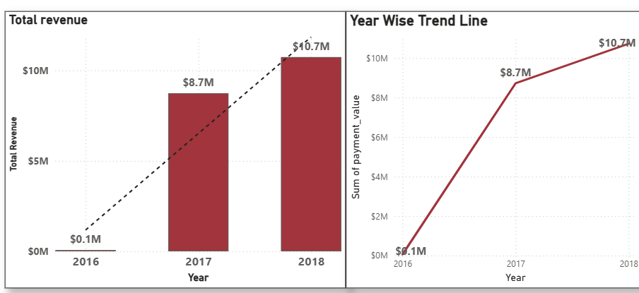

A Bar chart shows total revenue generated over years. It highlights revenue growth and changes over time, supporting strategic planning and investment decisions.

Another one is trend line chart gives us insights of growth in years.